Communication Plan & Products

Description: USDA’s Ohio Natural Resources Conservation Service (NRCS) is accepting applications from landowners interested in restoring, enhancing, and protecting wetlands with financial and technical assistance through the Wetlands Reserve Easement Program (WRE). The deadline to receive fiscal year 2023 funding is February 17, 2023.

Wetland Reserve Easements can help landowners protect land from development, restore critical wildlife habitat for outdoor recreation, and improve water quality by filtering sediments and reduce flooding. We would ask for our partners to help spread awareness of the program and its benefits through the use of the following materials. Please feel free to post on your own websites, social media pages and send out to any distribution lists.
Video
NRCS Wetland Reserve Easements. Length 00:25.
https://youtu.be/qHtcO99nC34
Learn more and sign up for the Natural Resources Conservation Service Wetland Reserve Easements (WRE) here: https://bit.ly/3tyifkw. The WRE program can help landowners protect land from development, restore critical wildlife habitat for outdoor recreation, and improve water quality by filtering sediments and chemicals and reducing flooding.
Social Media Accompanying Text (Photo files on page 2 and page 3)
Leave a Legacy Tweet: Clean water, wildlife habitat, and recreation. What legacy do you want to leave for your children and grandchildren? Sign up for the @NRCS_Ohio Wetland Reserve Easement program by Feb. 17, 2023: https://bit.ly/3tyifkw
Protect Your Land Tweet: Ohio’s natural places need your protection more than ever. Enjoy the privacy and recreational opportunities that the @NRCS_Ohio Wetland Reserve Easement Program can provide. Sign up by Feb. 17, 2023: https://bit.ly/3tyifkw
Improve Ohio’s Water Quality Tweet: Wetlands act like filters, trapping sediment and reducing flooding. Learn how you can help improve Ohio’s water quality through the @NRCS_Ohio Wetland Reserve Easement Program can provide. Sign up by Feb. 17, 2023: https://bit.ly/3tyifkw
Attract Wildlife Tweet: There's no denying the thrill of spotting wildlife in their natural habitat. Conservation programs like the NRCS Wetland Reserve Easement program play an important role in restoring and protecting critical habitat. Learn more and sign up by Feb. 17, 2023: https://bit.ly/3tyifkw

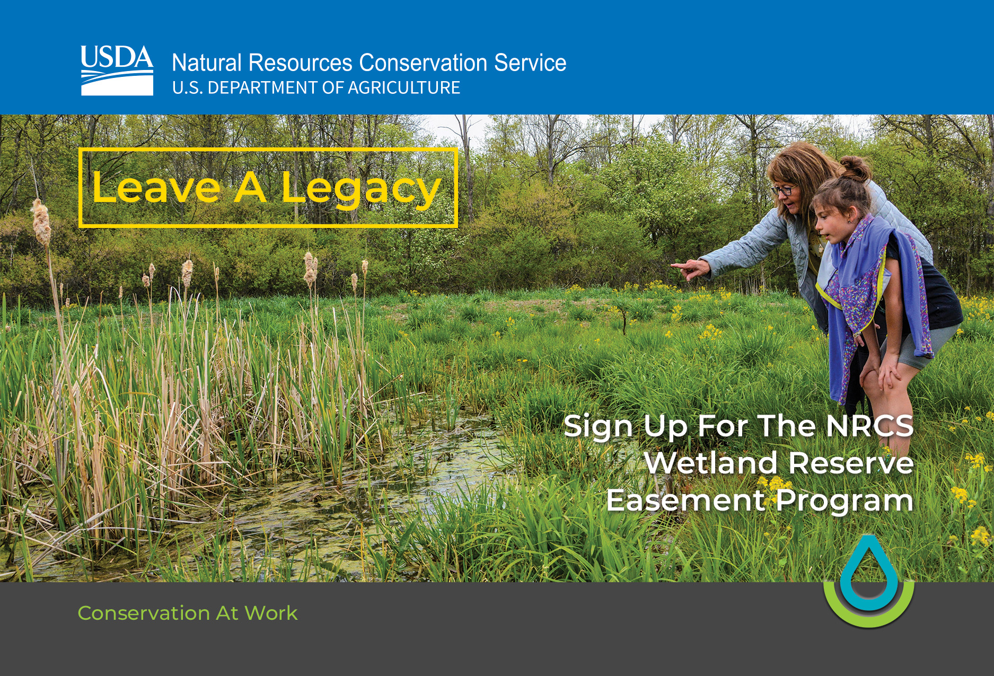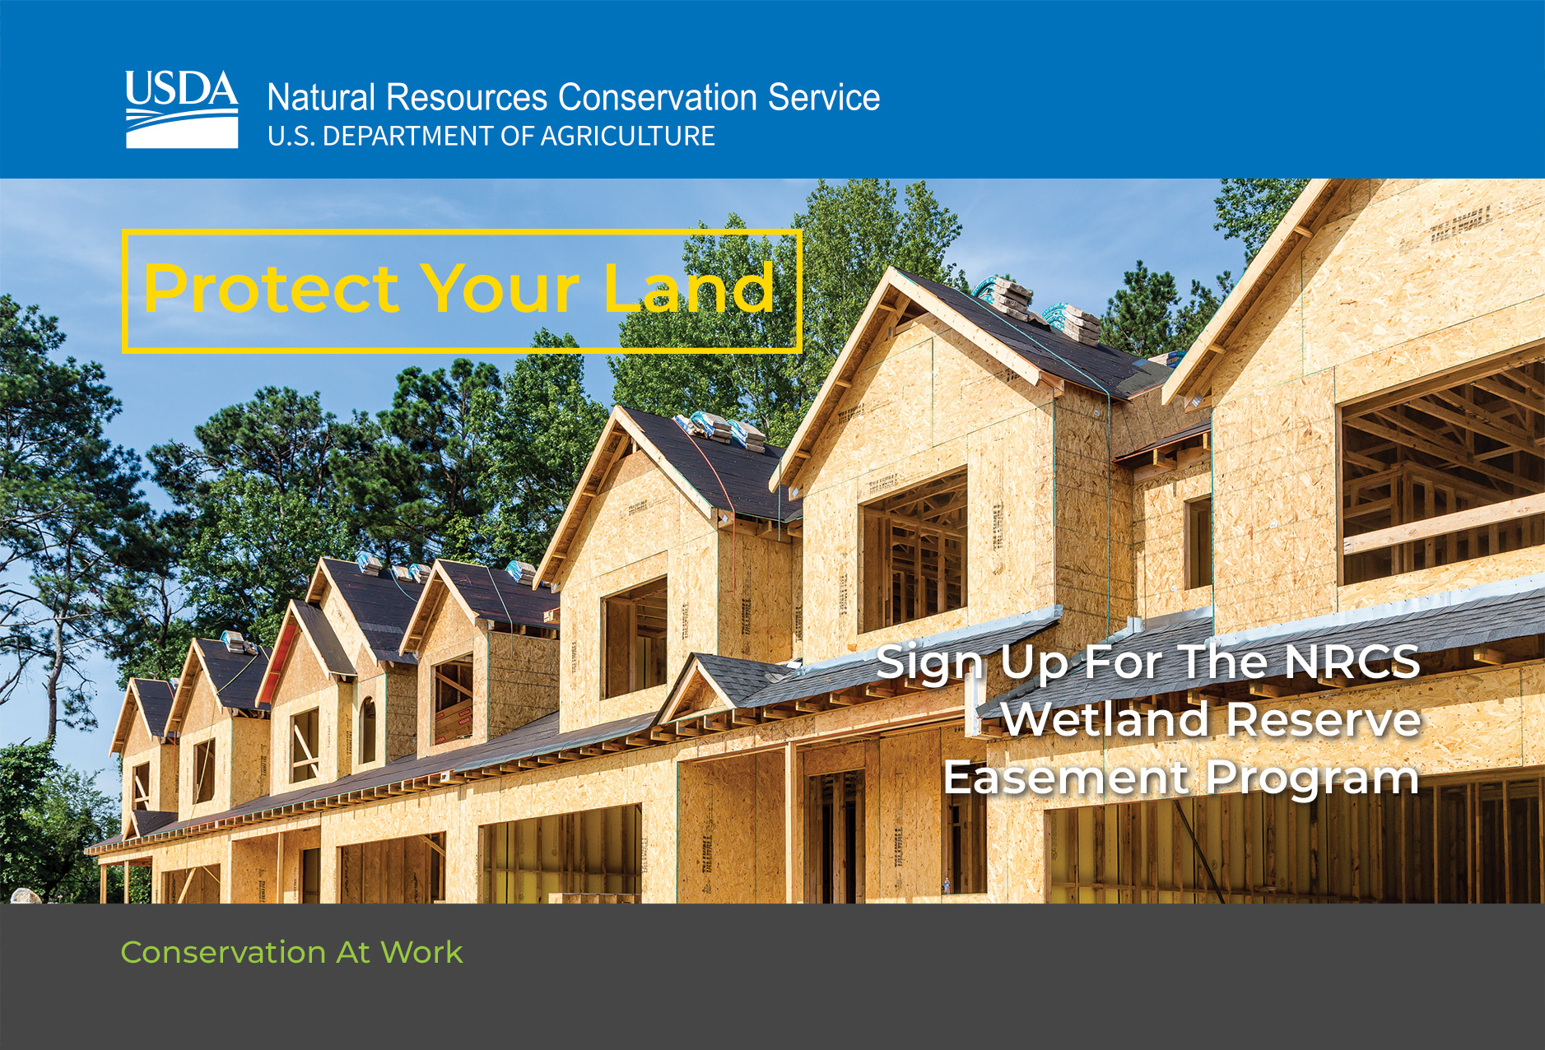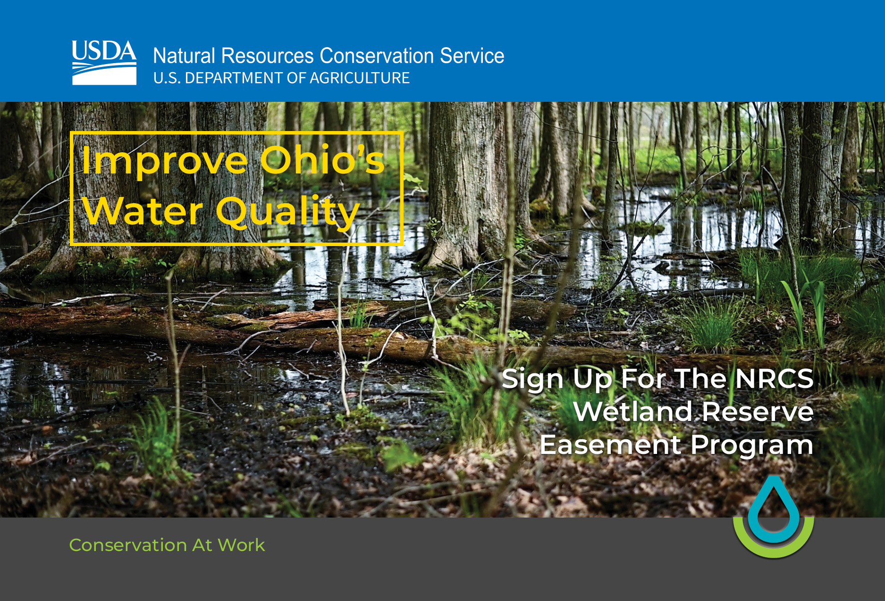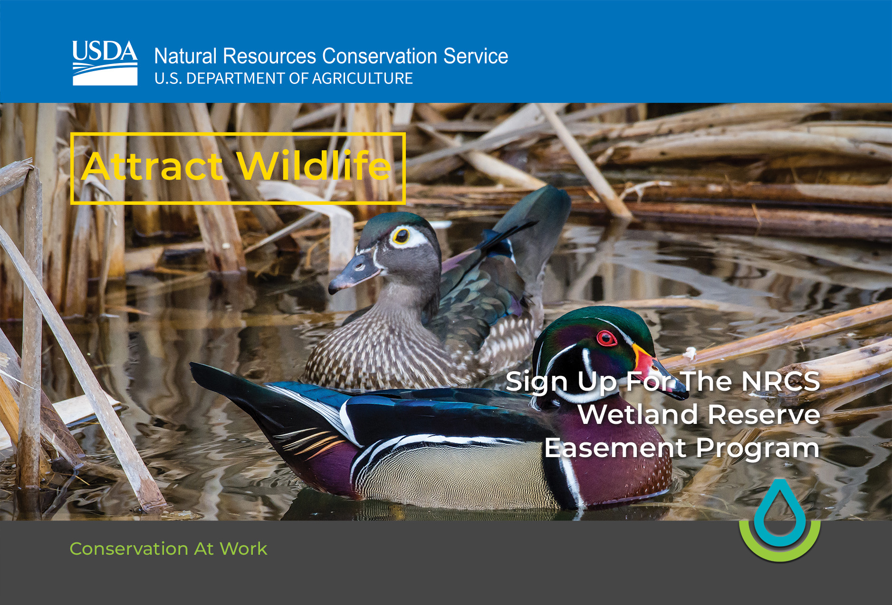

GovDelivery Bulletins
Please feel free to send out to your email distribution lists. Thank you for your help in spreading the word!

Posters for Public Places
Potential posting locations: Bass Pro Shop, Dick’s Sporting Goods, shooting range facilities, gun stores, REI, SWCDs, etc. Before placing a poster inside a business premises, it is common courtesy to ask a member of staff for permission first – try and speak with the manager or other leadership-level members. Be polite and if you are refused, thank them for their response anyway.

